<ASEC user requirementS AND SPECIFICATIONS>

Version <1.0>

<06/14/2015>

TABLE OF CONTENTS

**1** OVERVIEW**2**

1.1 Introduction2

1.2Executive Summary of User Requirement2

1.3Executive Summary of Project Charter2

1.4Executive Summary of Project Plan3

1.5Assumptions/Constraints3

1.6 Definitions, Acronyms, Abbreviations 3

**2** THE ASEC SYSTEM**4**

2.1 Scope of the System/Target Objectives 4

2.2Technical Challenge4

2.3Technological Requirements4

**3** CONTEXT DIAGRAM**6**

**4** BUSINESS USE CASE 6

**5** PRODUCT USE CASE15

5.1 Functional Requirements15

5.2Use Case Diagram22

# OVERVIEW

## Introduction

The purpose of this user requirement will aid in the deployment of the AUN Security Management System (ASEC). This document was produced by the ASEC project team after gathering information and requirements from stakeholders on various business processes in the department. In gathering the requirements, we met with our stakeholders consistently until we arrived at a requirement document that is deemed valuable enough to build our software web-based system. The method used in gathering these requirements involves interviews as well as brainstorming. This document is also essential for highlighting certain technologies needed to successfully deploy the proposed system. The intended audience of the *ASEC* user requirement is all project stakeholders including Dr. Lionel Rawlins and his Security Department and various departments of AUN that will provide certain technologies needed by the project team for the successful deployment of the system. This document is flexible and can be updated each time the requirements changes.

## EXECUTIVE SUMMARY of user requirement

The user requirement document based on the information gathered from stakeholders highlight the department’s business process in a simplified manner as well as summarizes the model of the proposed system to the stakeholders using information system tools such as business use case, activity diagrams, product use case, use case diagram, system context diagram, etc. which are contained in this document. This document also entail functional and non-functional requirements of the system as well the technological requirements for the system.

## Executive SuMMARY OF PROJECT CHARTER

The ASEC project charter tends to highlights in general the roles and responsibilities of the project team, the team purpose, the system development that deals with the background details such as problem statement, proposed solution to problem, scope, work duration and time commitment, members, supporting resources, reporting plan and deliverables.

The project charter is a separate document attached alongside this document.

## EXECUTIVE SUmmary of PROJECT PLAN

The ASEC project plan outlines the management of the project from inception to the end. It entails the management of the triple constraints of a project: Scope, schedule and budget. Also, it highlights the deployment and implementation plan, work breakdown structure, milestones list, project schedule, as well as change control, communication, risk, issue, procurement management.

The project plan is a separate document attached alongside this document.

## ASSUMPTIONS/CONSTRAINTS

**Assumptions:** The security department do not have an already existing system that performs the task ASEC does.

**Constraints:** The constraints are schedule, scope and budget.

## Definitions, acronyms and abbreviations

The following is a list of definitions and acronym meanings contained in this document:

|  |  |
| --- | --- |
| ASEC | AUN Security Management System |
| CSO | Chief Security Officer. |
| Premises | An entry location such as AUN Main Campus, AUN North Campus, etc. |
| Context diagram | A diagram showing how this system fits with its external interfaces. |
| Business Use Case | This is the processing done in response to a business event. |
| Product Use Case | A functional grouping of requirements that will be implemented by the product; the part of the Business Use Case that the system developer decides to build as a product. |
| Use Case Diagram | A use case diagram is a graphic depiction of the interactions among the elements of a system. |
| Activity Diagram | A graphical sequence of a Business Use Case |

# THE ASEC System

The AUN security management system (ASEC) is a web-based application system. The system will be developed using these various programming languages: My SQL database, PHP, HTML, CSS, JavaScript, etc. The system will require that all security officers undergo a training to enable them familiarize themselves with the functions and the tasks the system performs for easy, efficient and effective use of the system. The ASEC system is aimed at automating the processes of the security department which will increase their performance. The major functions of the system includes validation, create officers schedule, creating and storing case records, creating and keeping records of officers shift/activity report, keeping records of officers information as well as their next of kin information and the system will help ease their hiring process.

# SCOPE OF THE SYSTEM/TARGET OBJECTIVES

* The system will keep records of employee/Security officers (employment Details).
* The system will keep records of student offences and also judicial case information handled or dealt with through the Security Department.
* The system will perform scheduling of security staffs across all the units of the AUN security department for all locations.
* The system will create access for employment application process and recruitments.
* The system will validate every individual entering the campus.
* The system will register as well as check visitors in and out.
* The system will be able to print various reports.

# Technical Challenges

* Hardware for the system, e.g. card scanner, computer devices at each security location on campus.
* Access to integrate with the already existing university database records to test the validation function.

# Technological Requirements

**SERVER**

Hardware

* RAM Size: 8 Gigabyte.
* Storage: Minimum 250 – 500 Gigabyte.
* CPU: Minimum 2.5GHz

Software (Duration: 6 weeks)

* Apache Web Server
* MySQL Database
* Windows OS

**CLIENT**

Hardware:

* Computer devices which may include laptops, desktops, phones, etc.
* Card scanners.

Software

* Web browsers.
* Windows OS for desktops and laptops.

**DATABASE**

* The ASEC system will be linked to the openERP database via an API.
* The system will only be granted read access to the database.
* The system should not be able to alter information on the openERP database.
* The system will need to know the structure of the openERP database.

# CONTEXT DIAGRAM

# 

# BUSINESS USE CASE

**VALIDATION**

Business Event: A person decides to enter premises

Business Use Case: Validation process

Trigger: A person approaches the premises

Pre-condition: None

Interested Stakeholders: Person, Chief Security Officer, Security Officer

Active Stakeholders: Person, Security Officer

Main Case Scenario

1. Identify the person
2. Get identification details from person
3. Check that it is the right person
4. Confirm person eligibility
5. Search the person thoroughly
6. Record entrance details
7. Grant person access to premises

Exception Scenario

E3.1 Person does not match identity information

E4.1 Person is not eligible to enter the premises

Outcome: Person has been validated and is granted access to the premises

**ACTIVITY DIAGRAM – Validation**

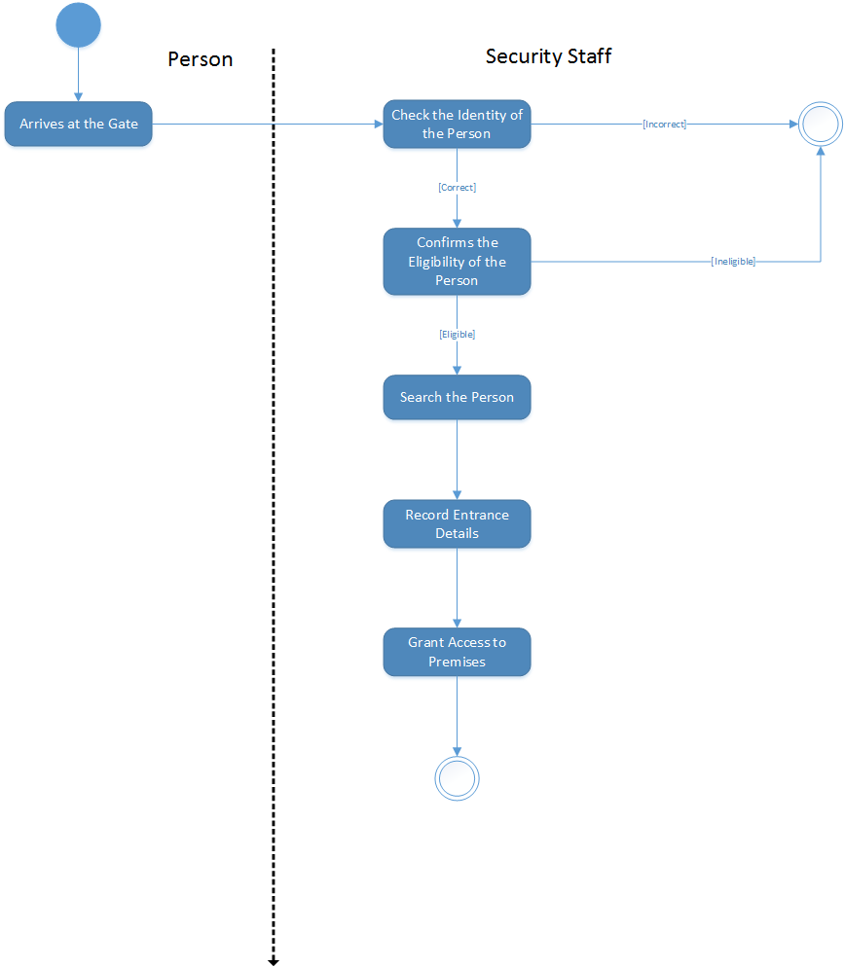

**CREATE CASE RECORDS**

Business Event: Student commits an offence

Business Use Case: Case records

Trigger: An offence has been committed

Pre-condition: Student has been validated to be on the premises

Interested Stakeholders: Student, Chief Security Officer, Security Officer, Surveillance Officer, Judiciary

Active Stakeholders: Security Officer, Chief Security Officer, Surveillance Officer

Main Case Scenario

1. Security Officer sees an offence
2. Security Officer reports student offence
3. Security Officer records the offence in his activity report
4. Chief Security Officer authorizes investigation
5. Surveillance Officer carries out investigation
6. Record details of investigation
7. Investigation report is given to Chief Security Officer for approval
8. Chief Security Officer recommends disciplinary action to Judiciary

Exception Scenario

E5.1 Investigation proves that student did not commit any offence

E7.1 Chief Security Officer does not approve of the investigation

Solution:  Redo step#5

Outcome: An investigation was carried out, the details were recorded, a disciplinary action was recommended and Student’s offence has been recorded.

**ACTIVITY DIAGRAM – Create Case Records**

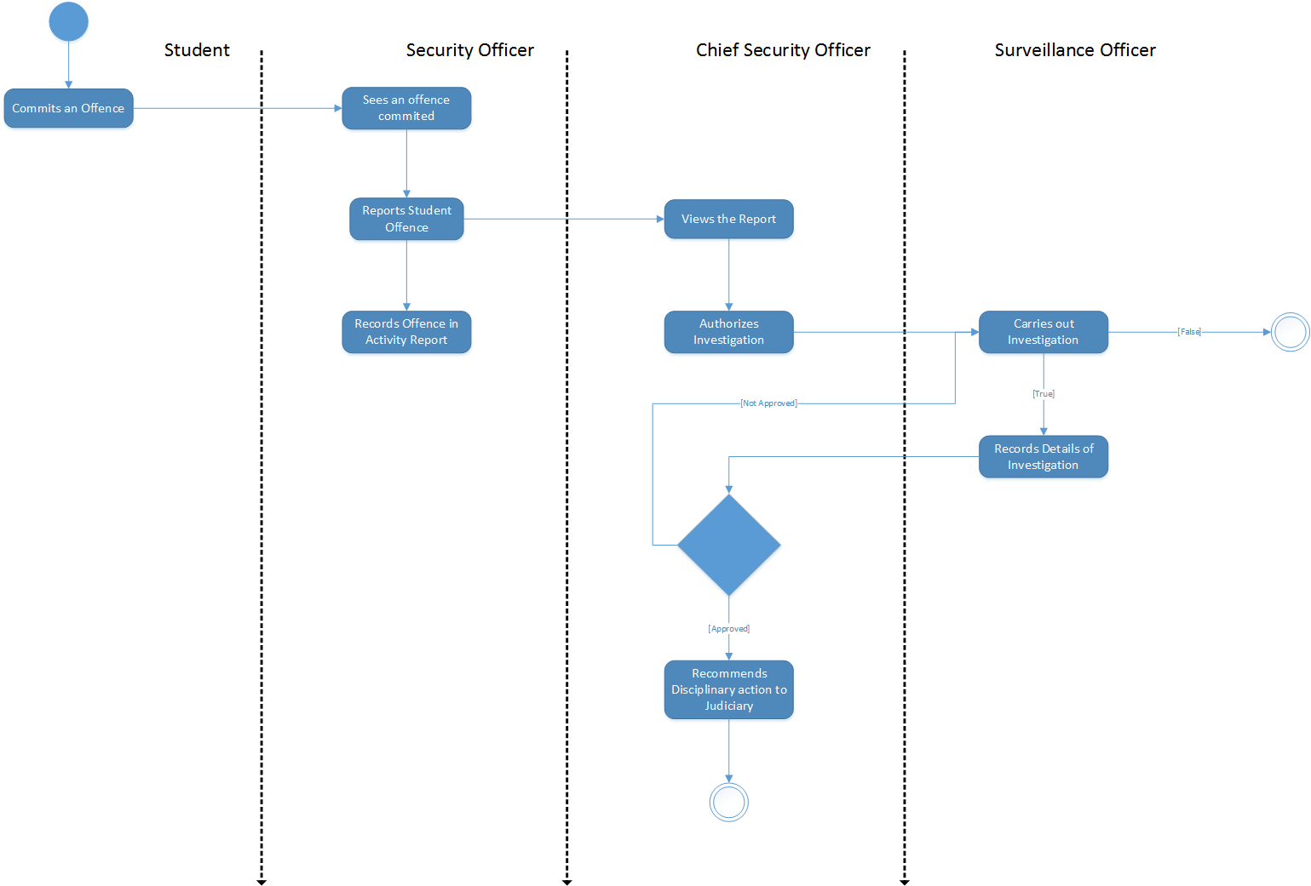

**CREATE ACTIVITY REPORT**

Business Event: A shift occurs

Business Use Case: Create activity report

Trigger: Security Officer’s shift starts

Pre-condition: Security Officer reports for duty at scheduled location

Interested Stakeholders: Chief Security Officer, Security Officer

Active Stakeholders: Security Officer

Main Case Scenario

1. Take inventory of everything at location
2. Take over shift
3. Carry out task
4. Record incidents
5. Handover shift

Exception Scenario

E1.1 Inventory items missing

Solution:  Report to supervisor who informs surveillance and documents the process

Outcome: Security Officer has reported on the activity that occurred during shift and this activity has been recorded.

**ACTIVITY DIAGRAM – Create Activity Report**

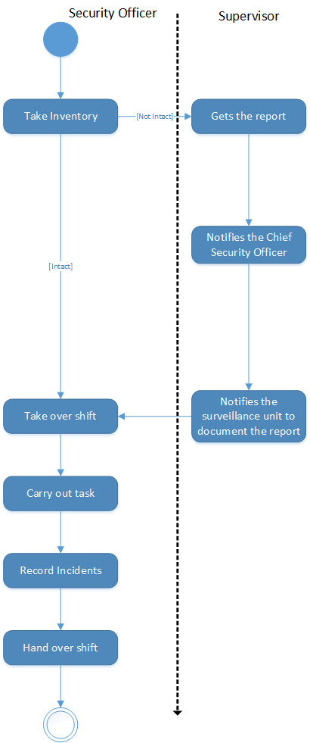

**HIRING PERSONNEL**

Business Event: Personnel Needed

Business Use Case: Hire new security officers

Trigger: Chief Security Officer decides to hire new personnel

Pre-condition: Employment vacancy

Interested Stakeholders: Committee, Applicant, Chief Security Officer

Active Stakeholders: Committee, Applicant, Chief Security Officer

Main Case Scenario

1. Chief Security Officer makes general announcement
2. Applicant submits Curriculum Vitae and application letter
3. Committee reviews applications
4. Committee selects first batch of successful applicants
5. Committee conducts interview
6. Applicant performs physical and intellectual training
7. Committee chooses successful candidates

Exception Scenario

E3.1 Applicant is not selected

E5.1 Applicant’s interview is not successful

E6.1 Applicant is unable to complete the training or does not perform as required

Outcome: New security officers have been hired.

**ACTIVITY DIAGRAM – Hiring Personnel**

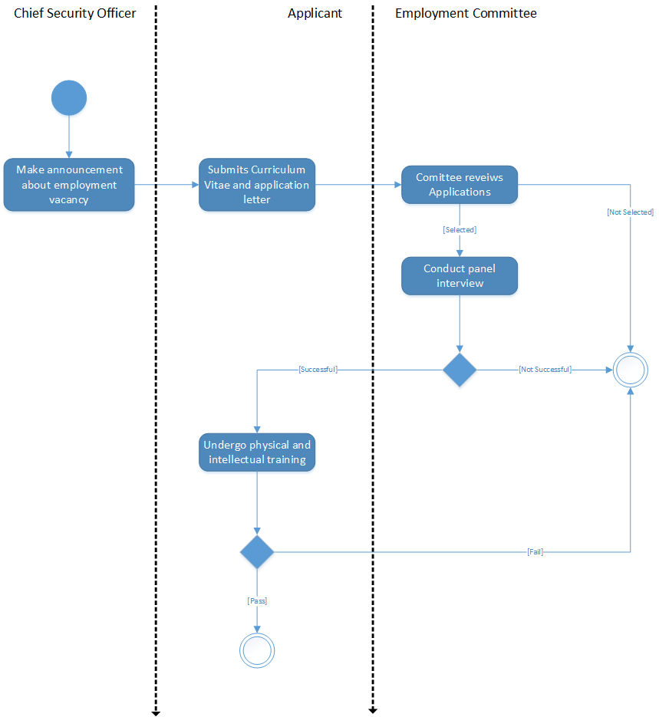

**CREATE SCHEDULE**

Business Event: Security Schedule

Business Use Case: Create new schedule

Trigger: New week

Pre-condition: Available Security Officers

Interested Stakeholders: Operations Manager, Chief Security Officer, Security Officers

Active Stakeholders: Operations Manager

Main Case Scenario

1. Select available Security Officers
2. Determine locations for posting
3. Determine number of Security Officers required for each location
4. Identify most suitable location for the Security Officers
5. Identify the most suitable shift for the Security Officers
6. Ensure the Security Officers have two days off
7. *\*ensure relief officers at various locations\**
8. Assign Security Officers to location for shift
9. Chief Security Officer approves schedule
10. Paste schedule on notice board

Exception Scenario

E9.1 Chief Security Officer does not approve schedule

Solution:  Redo step#8

Outcome: Schedule has been created.

**ACTIVITY DIAGRAM – Create Schedule**

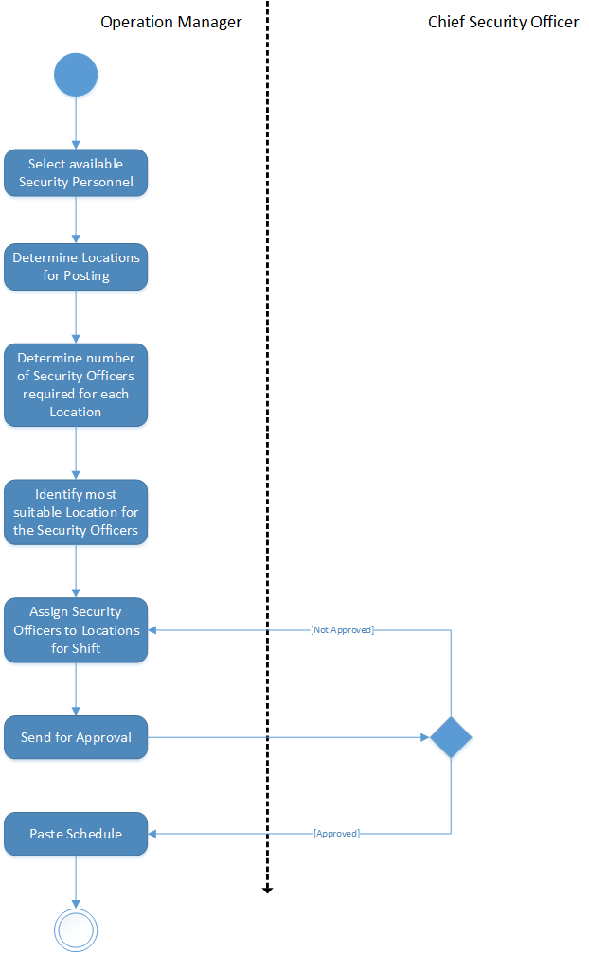

# PRODUCT USE CASE

# FUNCTIONAL REQUIREMENTS

## VALIDATION

Product Use Case Name: Validate prospective visitor

Actor(s): Security Officer

1. The product asks for the person’s identification number
2. The product verifies the identification details
3. The product provides confirmation of granted access to premises

Alternate Scenario (Visitor)

A1: The product records the person’s details, day, time and person visited

Functional Requirements

1. The product shall accept a valid identification number

      Rationale: To be able to identify the person that wants to gain access to the premises

1. The product shall verify that the identification number exists

Rationale: To ensure that the person is a member of the AUN community

Exception: If the identification number does not exist, the product shall display a warning message to deny the person access to the premises

1. The product shall allow the process to be cancelled by the Security Officer

Rationale: To able to account for the person not being cleared for entrance by the Security Officer on duty

1. The product shall display an access granted message

Rationale: To show that the person has been validated and can be allowed into the premises

1. The product shall generate statistics of number of visitors for the day

Rationale: The Chief Security Officer wants to be aware of people on campus

Alternate

1. The product shall accept the person’s name, other identification details, and the person being visited

Rationale: To store for record-keeping

1. The product shall record the time and day of the visit along with the accepted details (sign in)

Rationale: To store for record-keeping and generating reports

1. The product shall allow the person to be signed out when exiting the premises

Rationale: To ensure data integrity

**CREATE CASE RECORDS**

Product Use Case Name: Create Case Records

Actor(s): Chief Security Officer, Surveillance Officer

1. The product asks for student identification, type of offence, description of offence
2. The product records details of offence
3. The product sends offence record to CSO for authorization
4. The product asks for details of investigation
5. The product sends investigation report to CSO for approval
6. The product asks for recommendation of disciplinary action
7. The product sends recommendation to judiciary

Functional Requirements

1. The product shall accept a valid student identification number

      Rationale: To be able to identify the student that committed the offence

1. The product shall provide a list of offence types for selection

Rationale: To classify the offence for easy identification

1. The product shall accept a text description of the offence

Rationale: To be able to know what the offence is about

1. The product shall record information related to an offence

Rationale: To store for record keeping and reference to for investigation

1. The product shall notify the CSO of an offence

Rationale: The CSO authorizes investigation of an offence

1. The product shall allow the CSO to approve of an investigation into the alleged offence

Rationale: To make sure the offence is valid for investigation and that resources can be committed for the investigation

Exception: If CSO does not approve the investigation, the product shall notify of a terminated case

1. The product shall accept a text description of investigation report

Rationale: To store for record keeping, and ensure credibility of offence

1. The product shall request approval from CSO for the investigation carried out by a Surveillance Officer

Rationale: To determine if an action is to be taken on an offence

Exception: If the CSO does not approve, the product shall notify the surveillance officer to carry out another investigation along with proposed changes from the CSO

1. The product shall accept a text description of the CSO’s recommendation of disciplinary action

Rationale: To provide the Judiciary with an idea of what action to take

1. The product shall allow the CSO to set the severity of the case from a scale

Rationale: To enable broad classification of cases

1. The product shall compile case information

Rationale: For record keeping and detailed information about a case

1. The product shall notify the Judiciary of information about the case

Rationale: To enable them follow up on a case

**CREATE ACTIVITY REPORT**

Product Use Case Name: Create Activity Report

Actor(s): Security Officer

1. The product asks for review of inventory
2. The product asks for details of activity report

Functional Requirements

1. The product shall provide a list of inventory at the location

Rationale: To make inventory verification easier

1. The product shall request for verification of inventory

Rationale: To make sure everything is intact before a shift starts

Exception: If any inventory item is missing, the product shall notify the supervisor

1. The product shall accept a text description of activity report

Rationale: To store for record keeping and generating reports

**HIRING PERSONNEL**

Product Use Case Name: Hire Security Officer

Actor(s): Applicant, Committee

1. The product makes a general announcement
2. The product asks for Curriculum Vitae and Application Letter
3. The product reviews applications
4. The product provides confirmation of selected applicants
5. The product sends confirmation to successful candidates

Functional Requirements

1. The product shall allow the CSO to specify vacant employment positions

Rationale: To enable it make an announcement

1. The product shall allow the CSO to specify the requirements for the vacant employment positions

Rationale: To have a basis for removing unqualified applicants

1. The product shall make announcement of employment vacancy

Rationale: To make it known that there is hiring going on

1. The product shall accept a valid word document of Curriculum Vitae and Application Letter

Rationale: To enable applicants submit their application

1. The product shall provide a form for the applicants to fill

Rationale: To obtain extra information about the applicant

1. The product shall select eligible applicants by matching the requirements for the vacant position with the information filled in the form

Rationale: To reduce the workload of the committee by only presenting eligible applicants for further review

1. The product shall notify the committee of selected applicants

Rationale: The committee needs to know which applicants to review further

1. The product shall allow the committee to review the applications of selected applicants

Rationale: The committee needs to cut down on the number of applicants to interview

1. The product shall allow the committee to set the date, time and location of the interview after the review is complete

Rationale: To provide the details of the interview to the applicants during notification

1. The product shall notify selected applicants of interview date, time and location

Rationale: The selected applicants need to know when the details of their upcoming interview

1. The product shall allow the trainer to select applicants that passed the training

Rationale: The applicants will need to be notified

1. The product shall notify successful applicants

Rationale: The successful applicants will be notified for hiring and job placement

1. The product shall grant successful applicants access to the product

Rationale: The successful applicants will need to use the product for their daily jobs

Alternate

1. The product shall accept valid text input for Curriculum Vitae and Application Letter

Rationale: To enable applicants submit their application

## CREATE SCHEDULE

Product Use Case Name: Create new schedule

Actor(s): Operations Manager, Chief Security Officer

1. The product assigns available security officers to different locations and shifts
2. The product requests for approval from the CSO
3. The product informs all security officers to check their new schedule

Functional Requirements

1. The product shall select available security officers for assignment

Rationale: To be able to assign officers to locations

1. The product shall verify that selected security officers are not on leave

Rationale: To ensure that every location has the adequate number of officers

1. The product shall assign selected security officers to locations and for shifts

Rationale: To ensure security officers are assigned responsibilities

1. The product shall ensure that there are the required number of security officers assigned to each location

Rationale: To ensure that each location is being protected adequately

1. The product shall ensure that each security officer has two days off

Rationale: To prevent overworking any security officer

1. The product shall request for approval from the CSO for the created schedule

Rationale: To ensure that the CSO is aware of the new schedule

1. The product shall notify all security officers of the newly created schedule

Rationale: To inform them of the schedule change so that they can check it

**Other Functional Requirements**

1. The product shall allow the security officers to view their weekly schedule

Rationale: The security officers need to know what location and shift they have been assigned

1. The product shall allow the CSO to officers to view the entire weekly schedule

Rationale: The CSO wants to be able to check the schedule

1. The product shall allow the CSO to specify the location, security officers to filter the weekly schedule

Rationale: To be able to drill down on a location or security officer

1. The product shall provide a list of report types for selection by the CSO

Rationale: To enable CSO select and view a required report.

1. The product shall allow the CSO to view reports of the selected type

Rationale: To enable CSO make analysis and aid in some decision making.

1. The product shall allow the CSO to specify offence type, severity and date to filter the case records

Rationale: To enable fast retrieval of case records

1. The product shall allow Security Officers to request for annual leave by specifying start and end date

Rationale: To enable thesecurity officers make an annual leave request

1. The product shall request approval from the CSO for security officers’ annual leave

Rationale: To present the CSO with leave requests for approval

Exception: If the CSO denies the annual leave request, the product shall accept an optional text description of the reason for denial

1. The product shall inform the security officers of the CSO’s decision to their annual leave request

Rationale: To ensure security officers are aware of the status of their leave requests.

1. The product shall provide a list of all Security Officers

Rationale: To know the security officers the security department has

1. The product shall allow the Operations Manager to select a Security Officer record

Rationale: To ensure that the security officer his/her records on the database of the system.

1. The product shall allow the Operations Manager to specify location, shift of Security Officer records

Rationale: To enable the Operation Manager view records of security officer shifts and the location they were assigned to

1. The product shall allow the Operations Manager to view leaves of a Security Officer

Rationale: To enable the Operations Manager know the number of security officers available for scheduling

## USE CASE DIAGRAM

## 